|  |  |  |  |
| --- | --- | --- | --- |
| **TITLE:** | AR-04 Maintaining Customer Information | | |
| **sop #:** | QAF-03 | **revision #:** | 1 |
| **EFFECTIVE DATE:** |  | | |
| **OWNER:** |  | | |

## REVIEWERS

|  |  |  |  |
| --- | --- | --- | --- |
| Name | tITLE | sIGNATURE | dATE |
| Ron McDowell | Distribution Manager |  |  |
| Simer Purewal | Distribution Manager |  |  |
| Travis Cahill | Distribution Manager |  |  |
| Barry Stevens | Project Manager, Warehouse Operations |  |  |

## APPROVER

|  |  |  |  |
| --- | --- | --- | --- |
| Name | tITLE | sIGNATURE | dATE |
|  |  |  |  |

# 1.0 purpose

Maintaining New Customer info in TEDS + EPICOR

# 2.0 SCOPE

Maintaining New Customer info in TEDS + EPICOR.

# 3.0 equipment

N/A

# 4.0 definitions

|  |  |
| --- | --- |
| **Definition** | **Explanation** |
|  |  |
|  |  |
|  |  |
|  |  |
|  |  |

# 5.0 Responsibility

|  |  |
| --- | --- |
| **Responsibility** | **Activity** |
|  |  |

# 6.0 policy

## 6.1 GENERAL

1. From the Main Menu, select Sales Menu - Customer Information Menu.
2. The Maintain Customer Information Screen will appear. (CUSTSALE01



## 6.2 Adding a New Customer

1. You can add new customers to TEDS, one at a time, using the procedures outlined
2. below.
3. There are three steps involved in adding a new customer:
   1. **Step 1** - Enter the Name, Address and Telephone Information
   2. **Step 2** - Enter the Billing Requirements
   3. **Step 3** - Save the new customer

## 6.3 Entering the Name, Address and Telephone Information

1. The first step in adding a customer to TEDS is to enter their name and address
2. information.
3. **To Enter the Customer’s Name and Address Information:**
   1. On the **Maintain Customer Information** screen, press **Enter** to move to the
   2. **Customer Name** field.
4. In the **Customer Name** field, type the name of the **Customer** you want to add.
5. A message will appear, stating “Record not found,
6. Do you want to add <Y/N>”
7. Type “Y” to add the Customer, or **“**N” to cancel the entry.

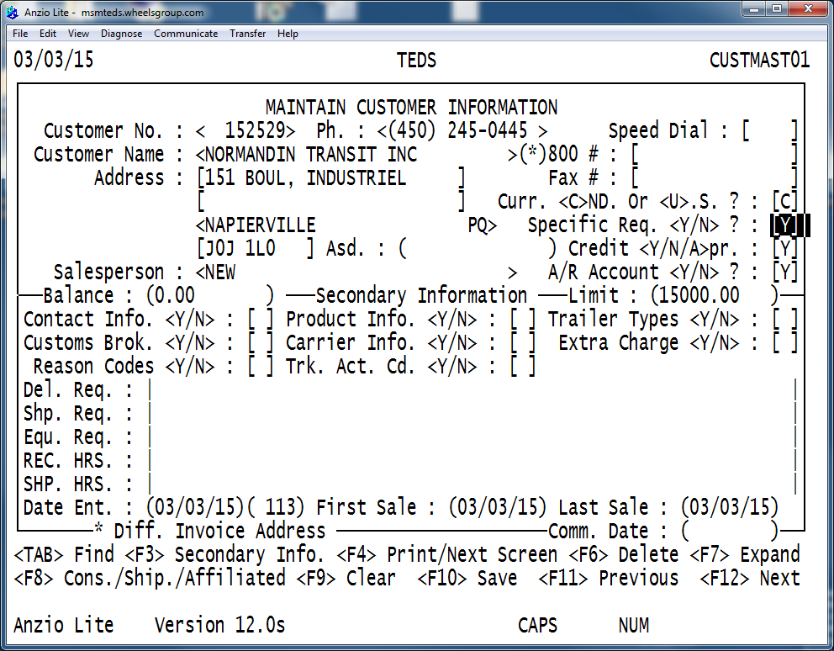

1. In the **Address** fields, type the complete address for the customer, including
2. Province/State and Postal Code.
3. In the **Salesperson** field, select the Salesperson being assigned to the

customer.

1. Before you can select a Salesperson, you must first add your Salespersons to
2. Type the **Phone Number** and, if applicable, the **Speed Dial** number, toll-free

**800** number and **Fax** number.

1. When you type the phone number and press **Enter**, TEDS will automatically

format it with the area code in brackets. Keep in mind, though, TEDS will not

format international phone numbers.

1. Type the company’s billing currency (Canadian or US) in the **Cur. <C>DN. Or**

**<U>.S.?** field. Type “C” for Canadian, or “U” for US.

1. The default currency you specify here will be automatically displayed in other

programs; however, you can override the default, if necessary.

1. The **Depart.** field will display the default department from the company
2. profile. You can override this default, if necessary.
3. In the **Billing Reqt. <Y/N>** field, type “Y” to enter the billing requirements for the Customer.
4. The TEDS screen will appear as shown in the sample below.

## 6.4 Entering the Billing Requirements

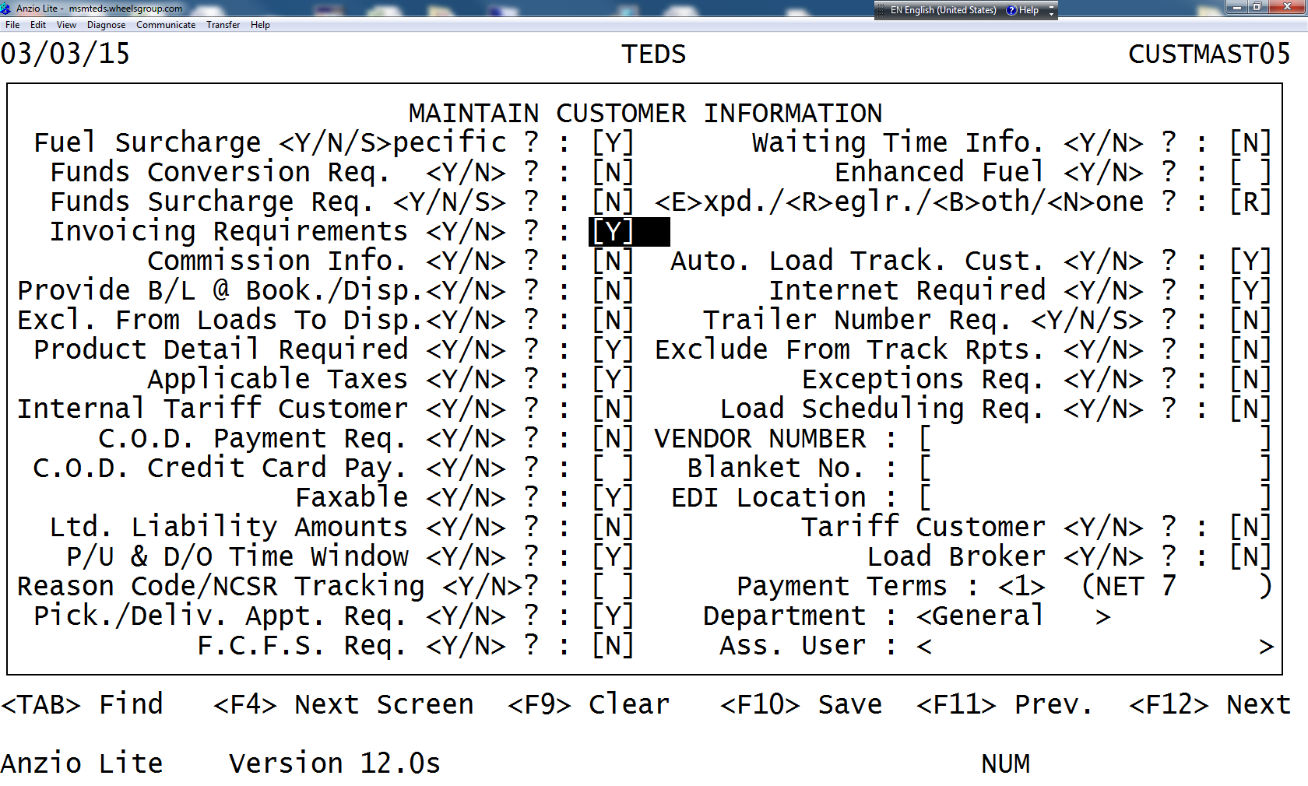

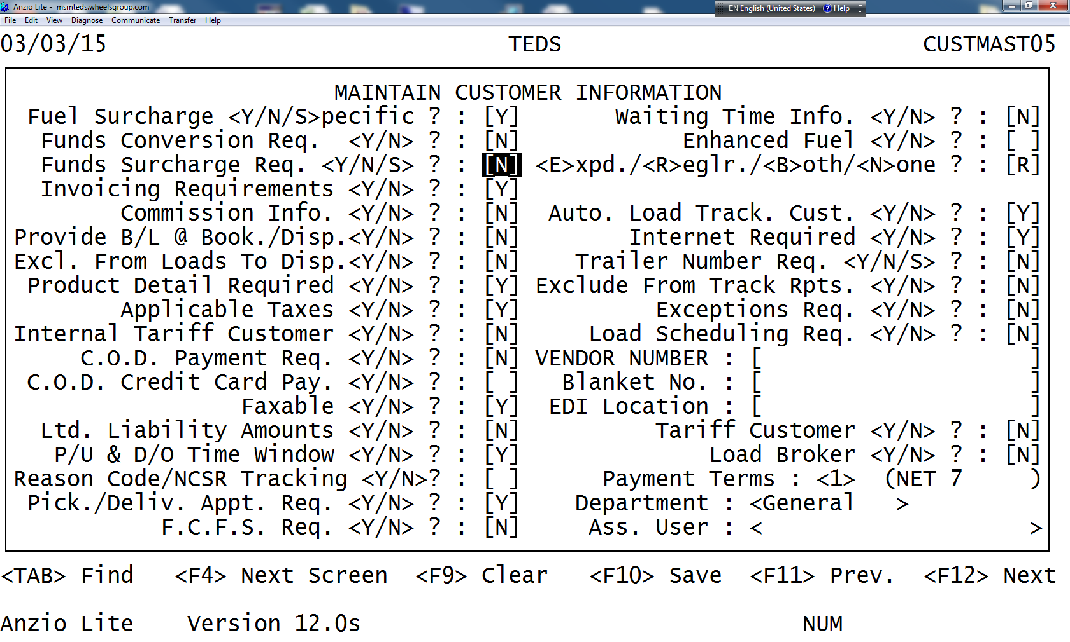

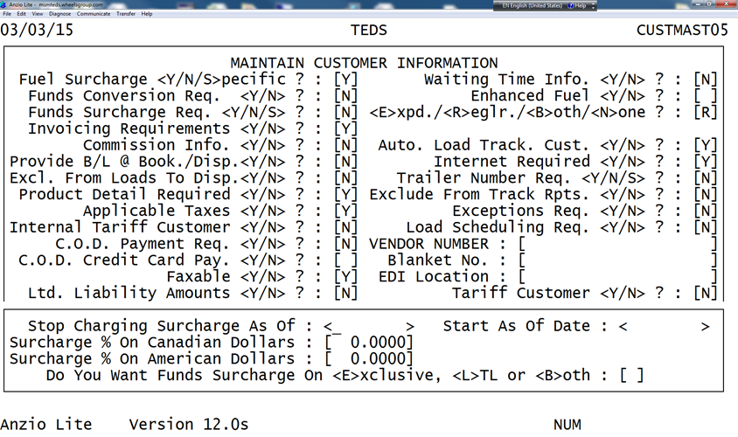

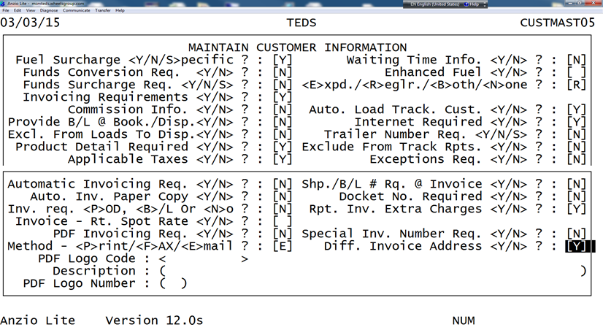

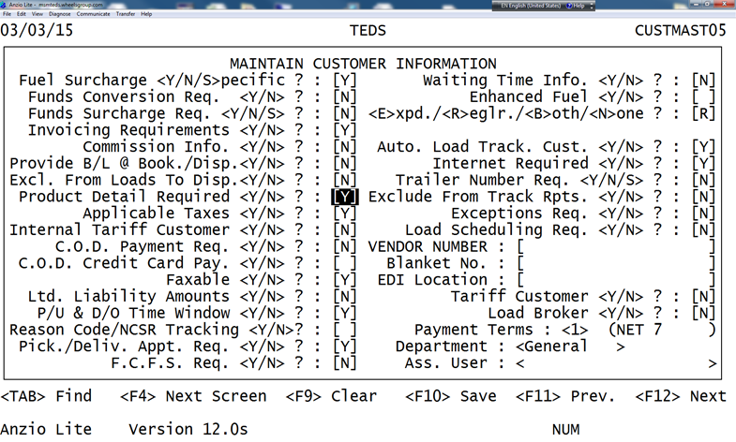

1. Depending on customer requirement, it can be different

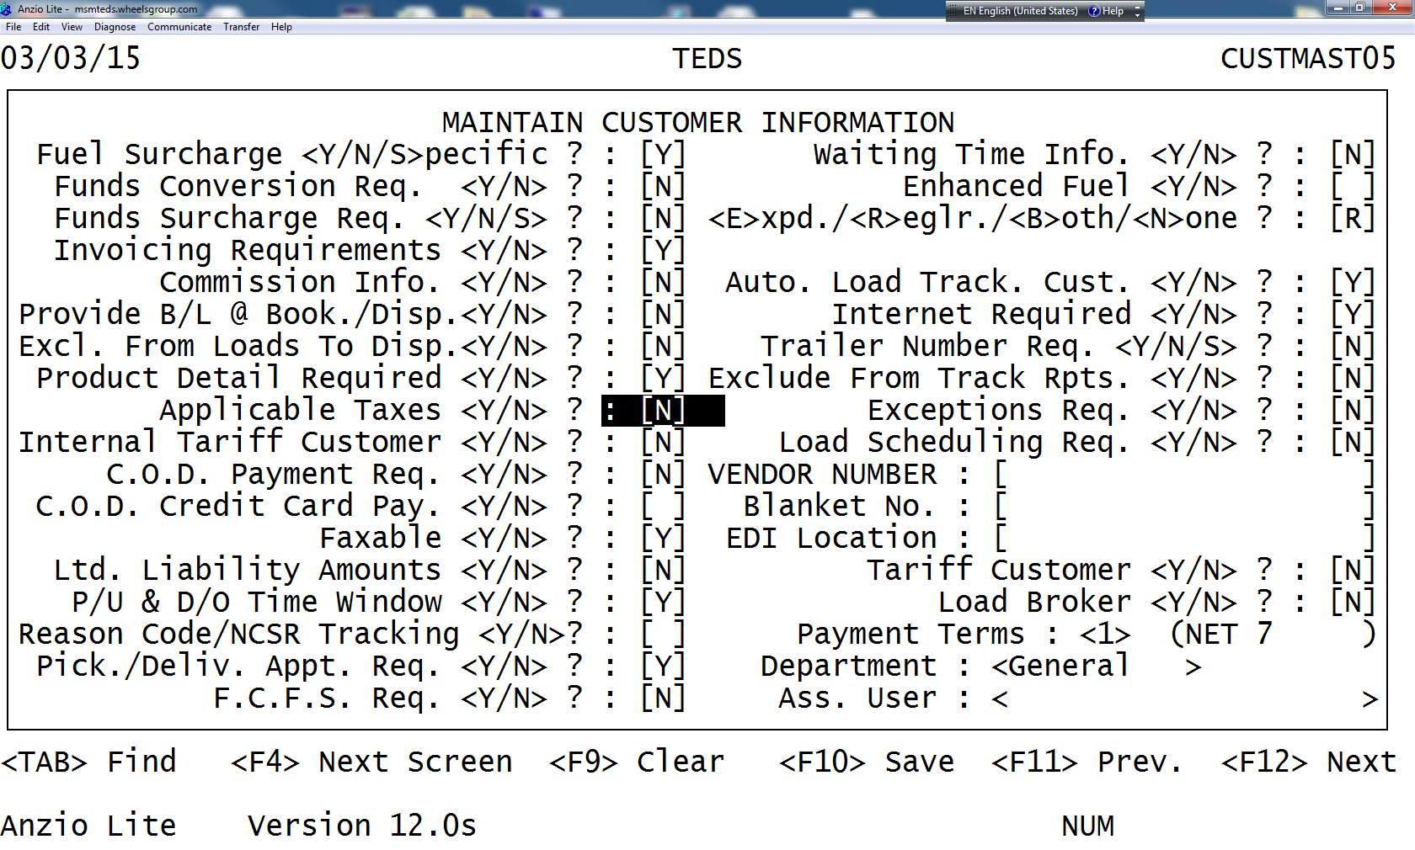

1. If the company is not freight forwarding then the taxes should be marked Y
2. If customer is COD then mark Y

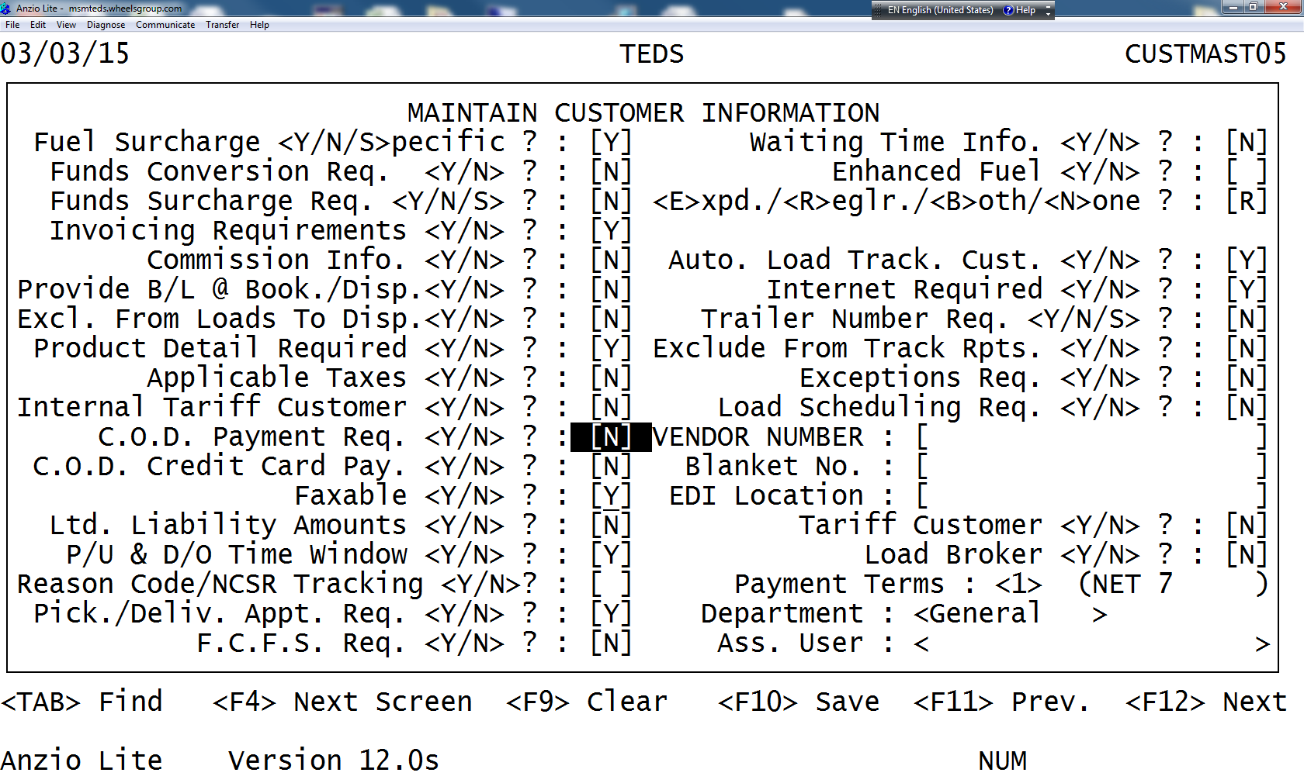

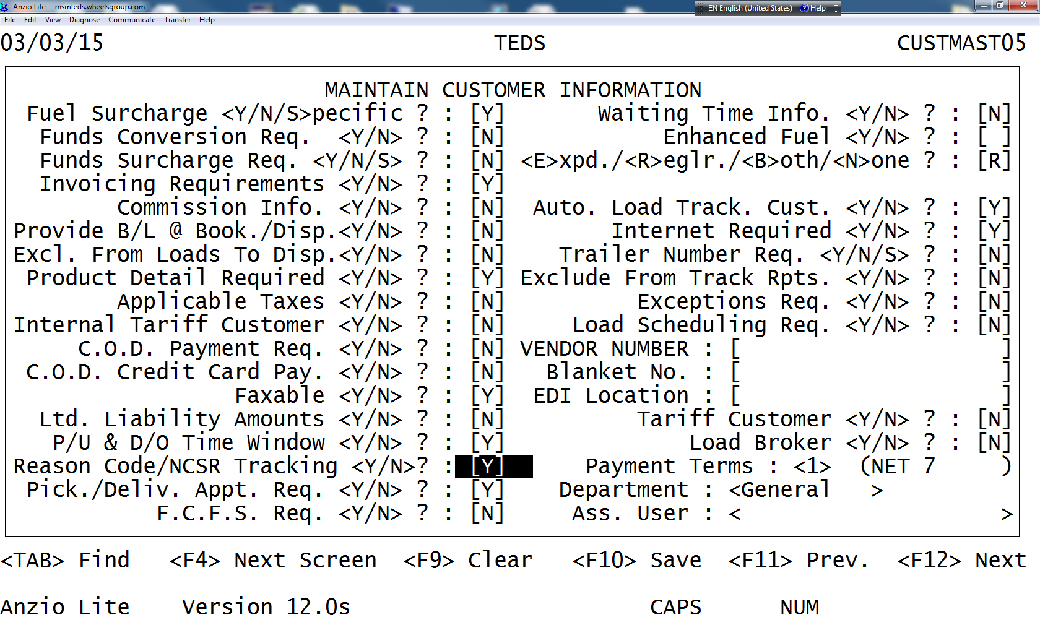

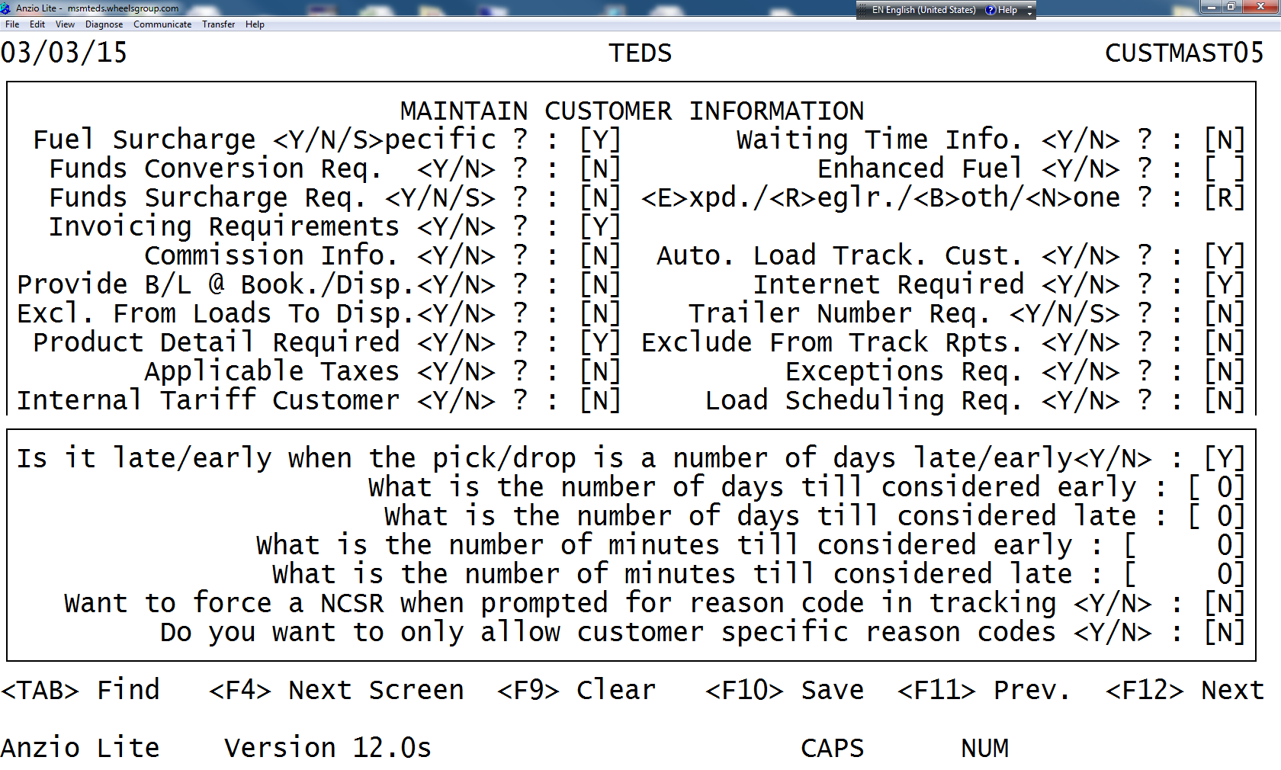

1. Select the Term

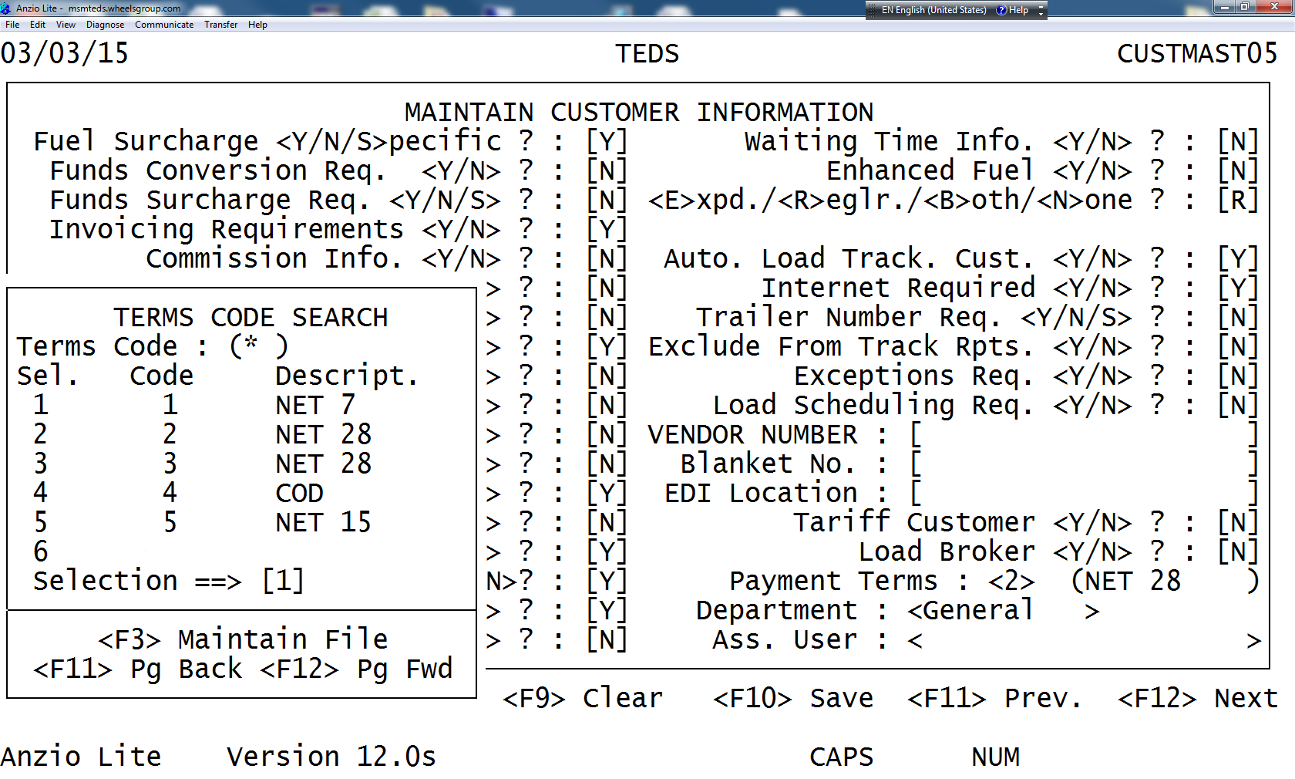

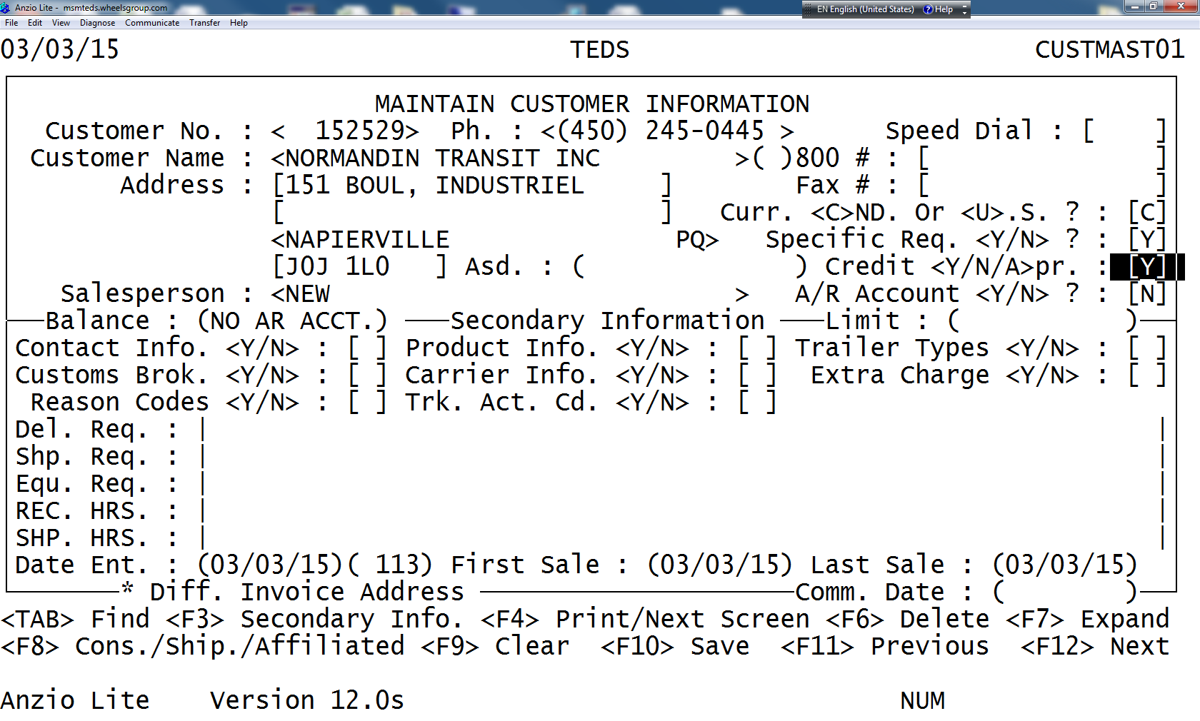

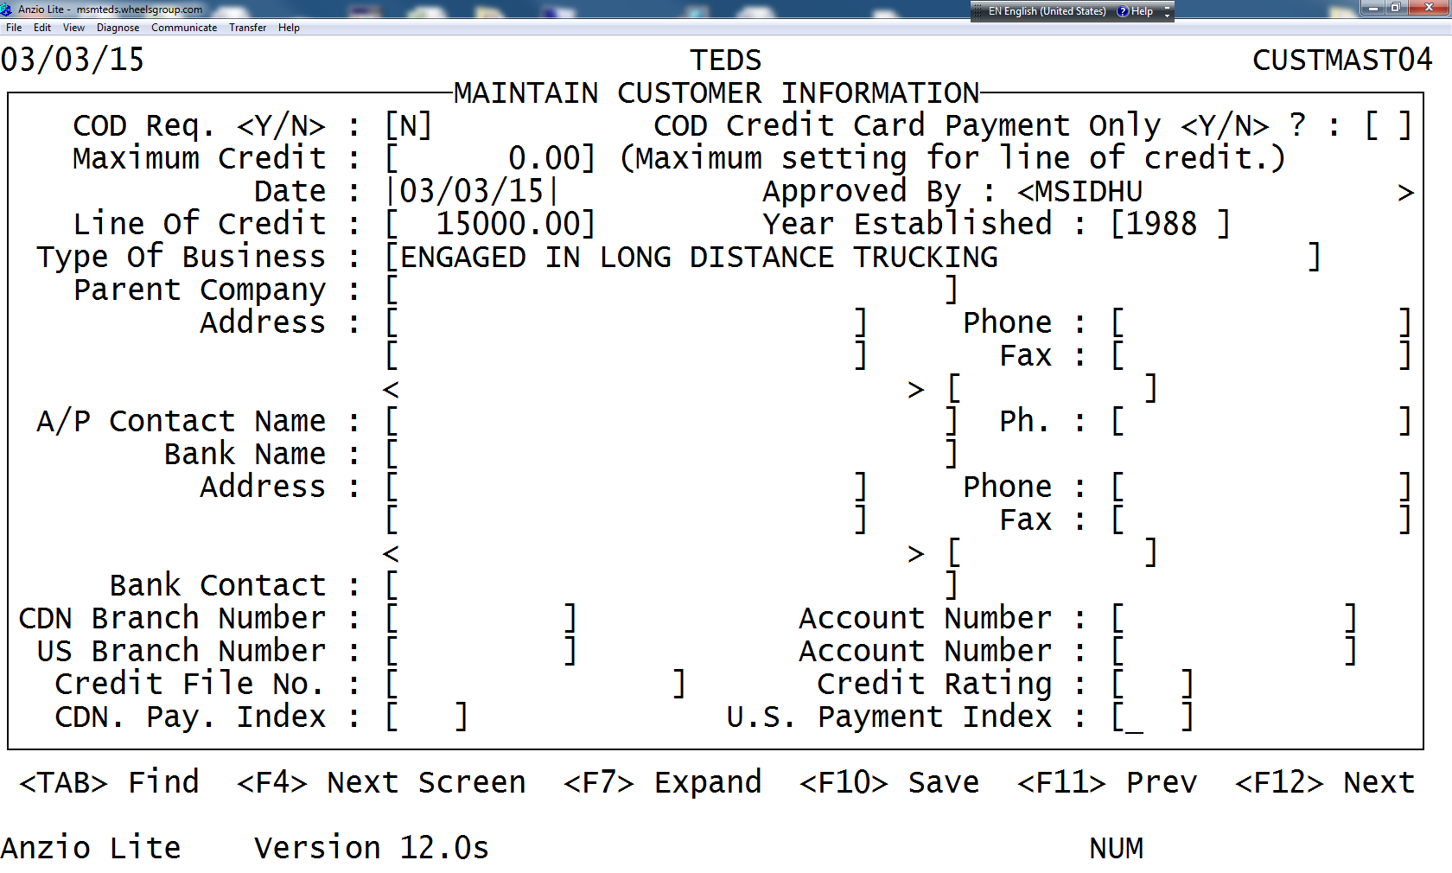

1. If the Parent Company exists

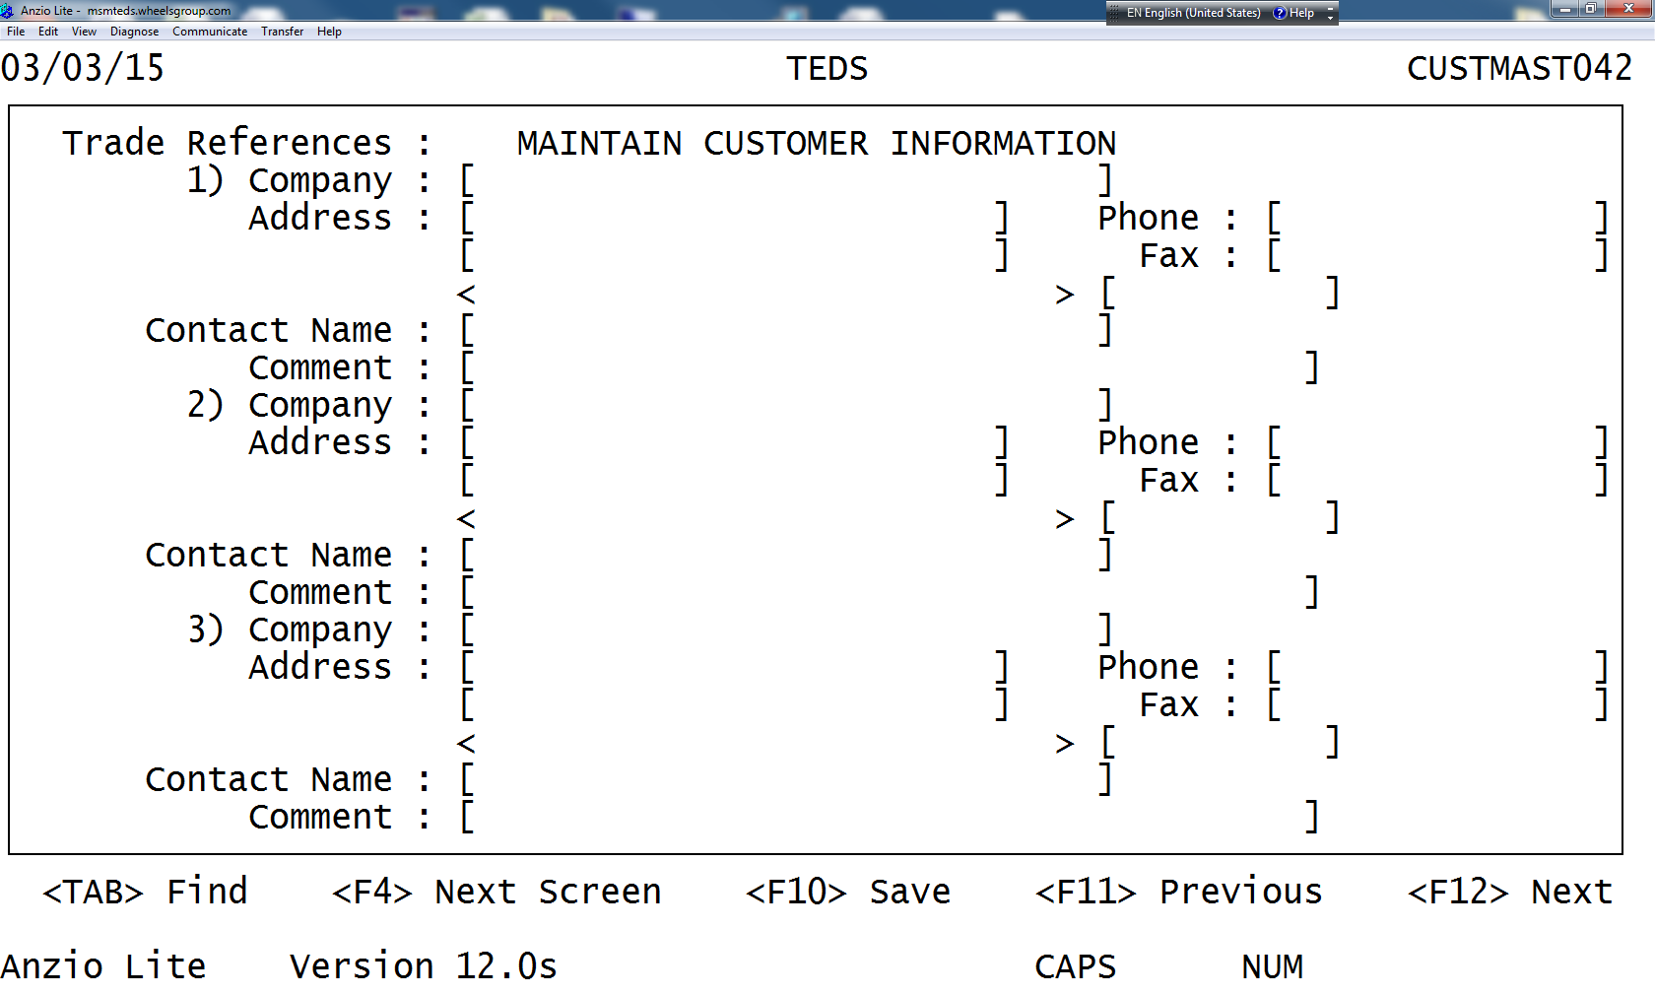

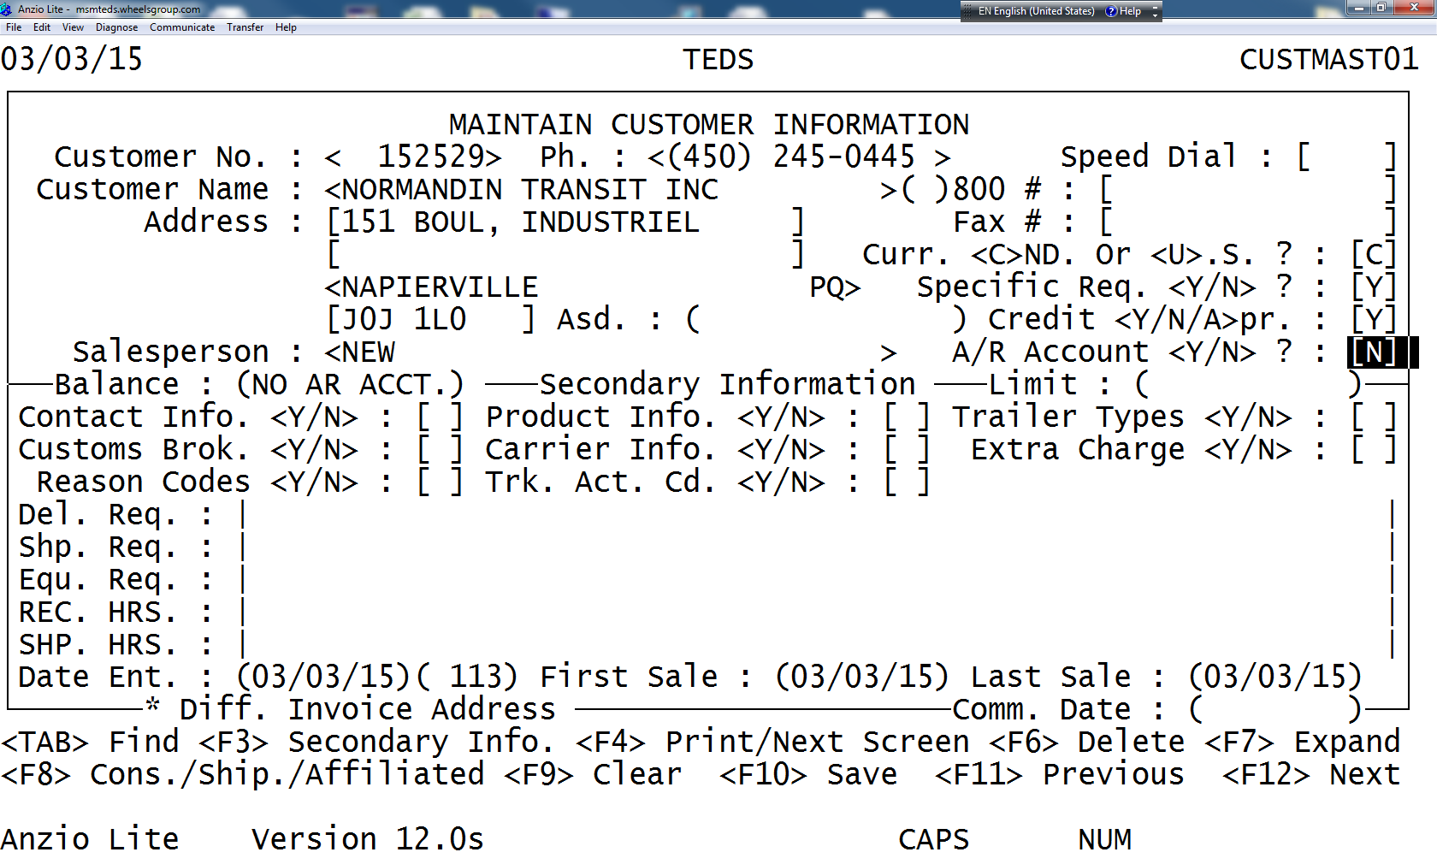

1. Enter Y – Enter

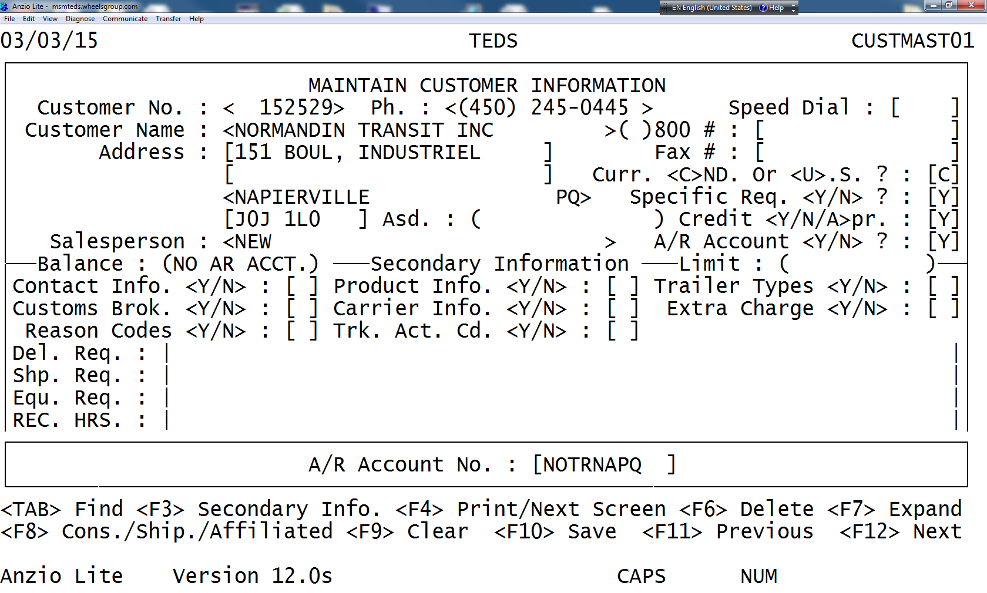

## 6.5 HOW TO SELECT CUSTOMER CODE

1. First four letters of company+2 letters from city + 2 province
2. F10 to save
3. Epicor
4. accounts receivable
5. customer wii only!

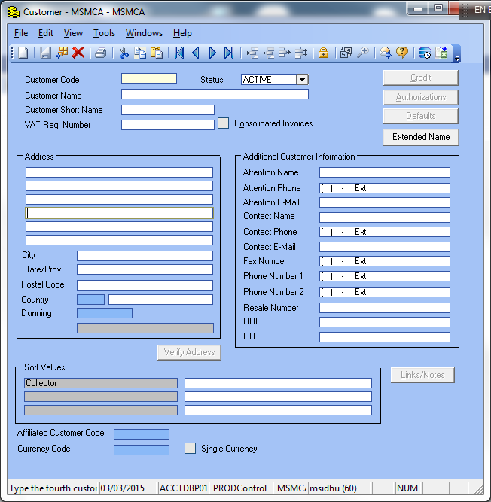

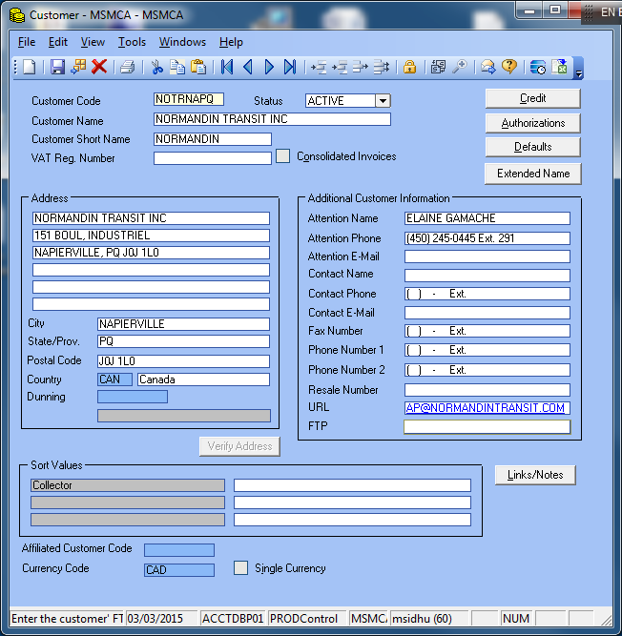

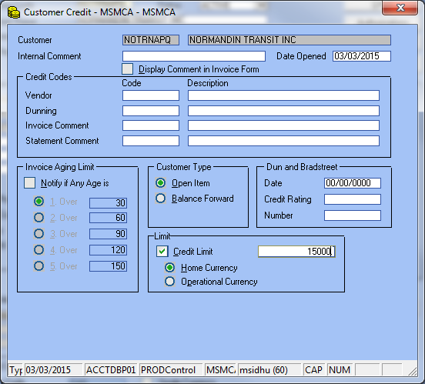

1. Close this screen
2. Click on defaults button

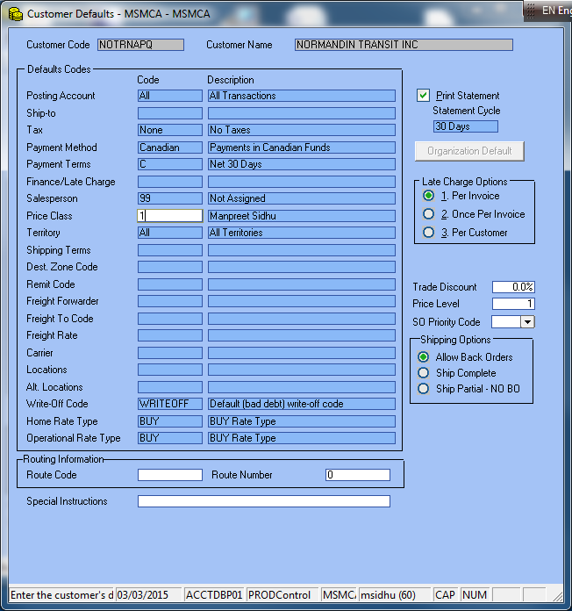

1. On this screen need to change
2. Payment terms if not 30 days
3. Salesperson
4. Price – collector code
5. Close that screen save

## 6.6 EDITING or Deleting Contact Information in TEDS

1. You can edit or delete customer contacts using the procedures outlined below.
2. To Edit or Delete Contacts:
   * 1. On the Maintain Customer Contacts Information screen, press F3 to move the cursor to the Customs Brok. field.
     2. In the Customs Brok. field, type “N” and then press Enter to move the cursor to the Contact Info. field.
     3. n the Contact Info. <Y/N> field, type “Y” and then press Enter again.
3. The Contact Information screen will appear.



* + 1. In the Contact Type field, type the contact type for the contact you want to

1. Edit or delete
2. In the Contact field, select the contact you want to edit or delete.
3. Do one of the following:
4. To edit a Contact, move through the fields and make your changes.
5. Once you are finished, press F10 to save.
   * 1. Press Escape “E” to return to the main screen.

# 7.0 references

# 8.0 revision history

|  |  |  |
| --- | --- | --- |
| **Revision #** | **Revision Date** | **Description** |
|  |  |  |